Advice following insertion of your

Intrauterine Contraceptive Device (IUCD)

Copper IUCD (CuIUCD): e.g. NovaT380, TSafe380

Intrauterine system (IUS): Mirena; Levosert; Kyleena, Jaydess

How should I feel afterwards?
Most women experience some period-like discomfort for 24-48 hours after fitting, which then usually settles.
There may be some bleeding or spotting for a few days. If an IUCD is fitted during a period, the period may be heavier and last slightly longer than usual.
If the pain is severe, gets worse or does not settle after 3 days you should contact your GP or Practice Nurse (or call 111 if the Practice is closed).

What should I do afterwards?
Take simple painkillers such as Paracetamol and/or Ibuprofen (as long as you are not allergic to these products).
Rest for several hours after fitting and avoid strenuous activity for the rest of the day.
Using a hot water bottle may help.

When can I resume sex?
A copper IUCD is effective straight away as contraception.
An IUS (Mirena/Levosert/Kyleena or Jaydess) will not work as contraception for the first 7 days and you should abstain from sex or use another contraceptive method at the same time.
Otherwise, you can resume sexually activity whenever you feel comfortable.

Is there anything I should look out for?
A change in bleeding pattern occurs frequently after your coil insertion. Irregular bleeding is particularly common with an IUS device but should settle after 3-6 months. With a copper IUCD periods can become heavier and more painful but then often improve after the first 3 months. If you are concerned about bleeding, please speak to your Practice Nurse or GP.
If you think you may have an infection, please contact the GP Practice as soon as possible.
Symptoms of an infection may include:
- Persistent or worsening lower abdominal pain
- Abnormal vaginal discharge
- Fever
- Pain during sexual intercourse

When does the coil need changing?
All intrauterine devices are effective for at least 5 years (except Jaydess) and some for up to 10 years. You should have been advised of the date for replacement at the time of fitting; if not, please ask. It is then your responsibility to attend your GP or local sexual health clinic before this date to have your coil removed or changed.
If you have had an IUS (Mirena or Levosert) fitted after the age of 45, (or a copper IUCD fitted after the age of 40), you can continue to use the same device for contraception until no longer required (usually at age 55).
A coil can be removed at any time but it is important to abstain from sex or use additional contraception for the seven days prior to removal/change of device. This is to avoid any risk of unintended pregnancy.
If you are planning to conceive, please speak to your GP. You may also find the following information useful: https://www.nhs.uk/pregnancy/trying-for-a-baby/planning-your-pregnancy/

Checking your threads
We recommend that you check for your coil threads ideally once a month, (after your period if you have them).
Wash your hands and sit or squat down.
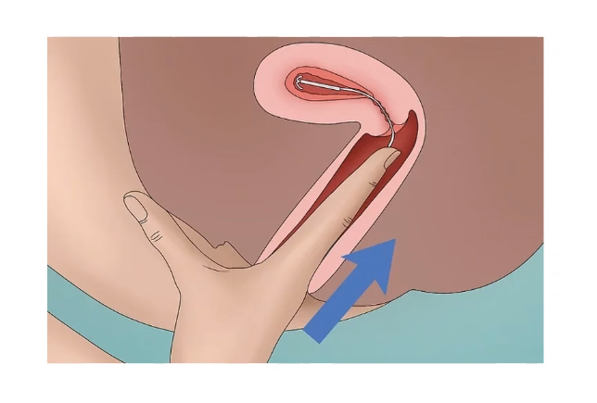
Gently put your finger inside your vagina (as if inserting a tampon). Feel for your cervix (which feels firm, like the end of your nose).
Gently roll your finger over your cervix and you should feel your threads. (Although there are two threads they usually stick together and you will only be able to identify them as one thread; this is fine).
It is unlikely that your coil will fall out, but if you cannot feel your threads, please abstain from sex or use condoms and make an appointment to have the device checked. If you think you may have had sex since the coil has moved you may need emergency contraception. Please seek advice as soon as possible.

Additional advice
We do not routinely see patients for follow up after a coil fit, but we are always very happy to see you if you have any concerns. Please contact the Practice for an appointment.
If you are aged 25 or over, make sure you have regular cervical smears as part of the National Cervical Screening Programme (you will receive a letter about this about 6 months before your 25th birthday).
We recommend regular sexual health checks for everyone, but especially if you have a new partner or believe you may be at risk.

For more information
For more information about IUCDs in general, please see: www.sexwise.fpa.org.uk/contraception/iud-intrauterine-device
www.sexwise.fpa.org.uk/contraception/ius-intrauterine-system

